Qatar NIA Compliance for Log360
Strengthen data protection and meet Qatar NIA compliance with Log360.
Region: Qatar | Type: Data Privacy, Cybersecurity Framework, Critical Infrastructure, Government/Public Sector, Incident Management | Category: Compliance | Pricing: Free

Overview
The Qatar NIA compliance extension in Log360 helps organizations meet the Qatar National Information Assurance Policy, a national cybersecurity framework issued by Qatar's NCSA covering 26 security domains for government entities and critical infrastructure operators by providing centralized log management, access control monitoring, network security auditing, and incident detection. The platform supports Qatar NIA requirements for security governance, access and identity management, network monitoring, incident response, audit logging, data protection, and privileged access management.
For Information Security Governance and Policy Management, Log360 monitors policy changes, GPO modifications, system events, and Entra ID policy management to verify governance controls are consistently applied across all systems. To address Access Control and Identity Management, the platform tracks logon events, failed authentication attempts, and network device access across Windows, Unix, and Active Directory to enforce least-privilege access controls. The extension also supports Network Security and Traffic Monitoring by providing capabilities that provides comprehensive coverage of network device rule changes, configuration updates, attack detection, policy management, and firewall security events to maintain network perimeter integrity.

Key Features
- Incident Management and Security Response: Log360 integrates threat intelligence from Trend Micro, FireEye, and native Windows and Unix threat detection to rapidly identify and respond to security incidents.
- Audit Logging and Continuous Monitoring: Log360 aggregates MFA events, system event logs, process tracking data, and GPO audit records into a centralized repository, enabling continuous monitoring and compliance evidence generation.
- Data Protection and Information Classification: Log360 audits file changes, removable media usage, registry modifications, cloud application activity, and cloud storage events to detect unauthorized data access or exfiltration.
- Privileged Access Management and User Rights: Log360 tracks Unix sudo commands, user group changes, account modifications, Microsoft 365 role assignments, directory management events, and password auditing to enforce privileged access controls.
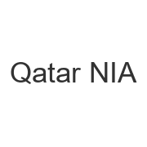
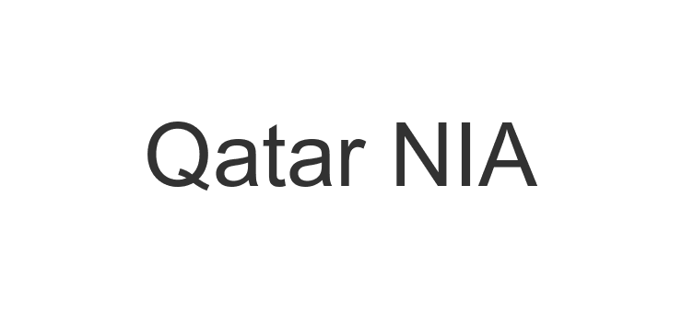
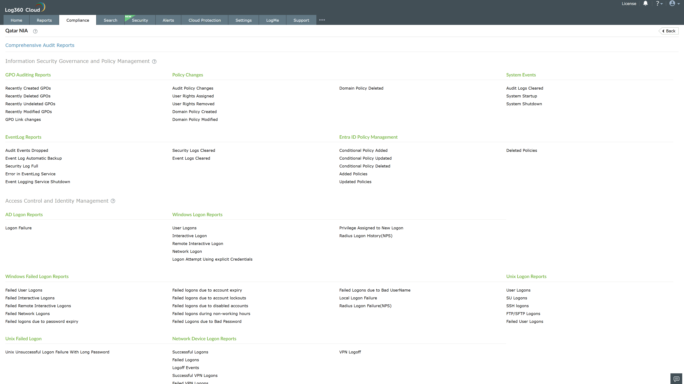
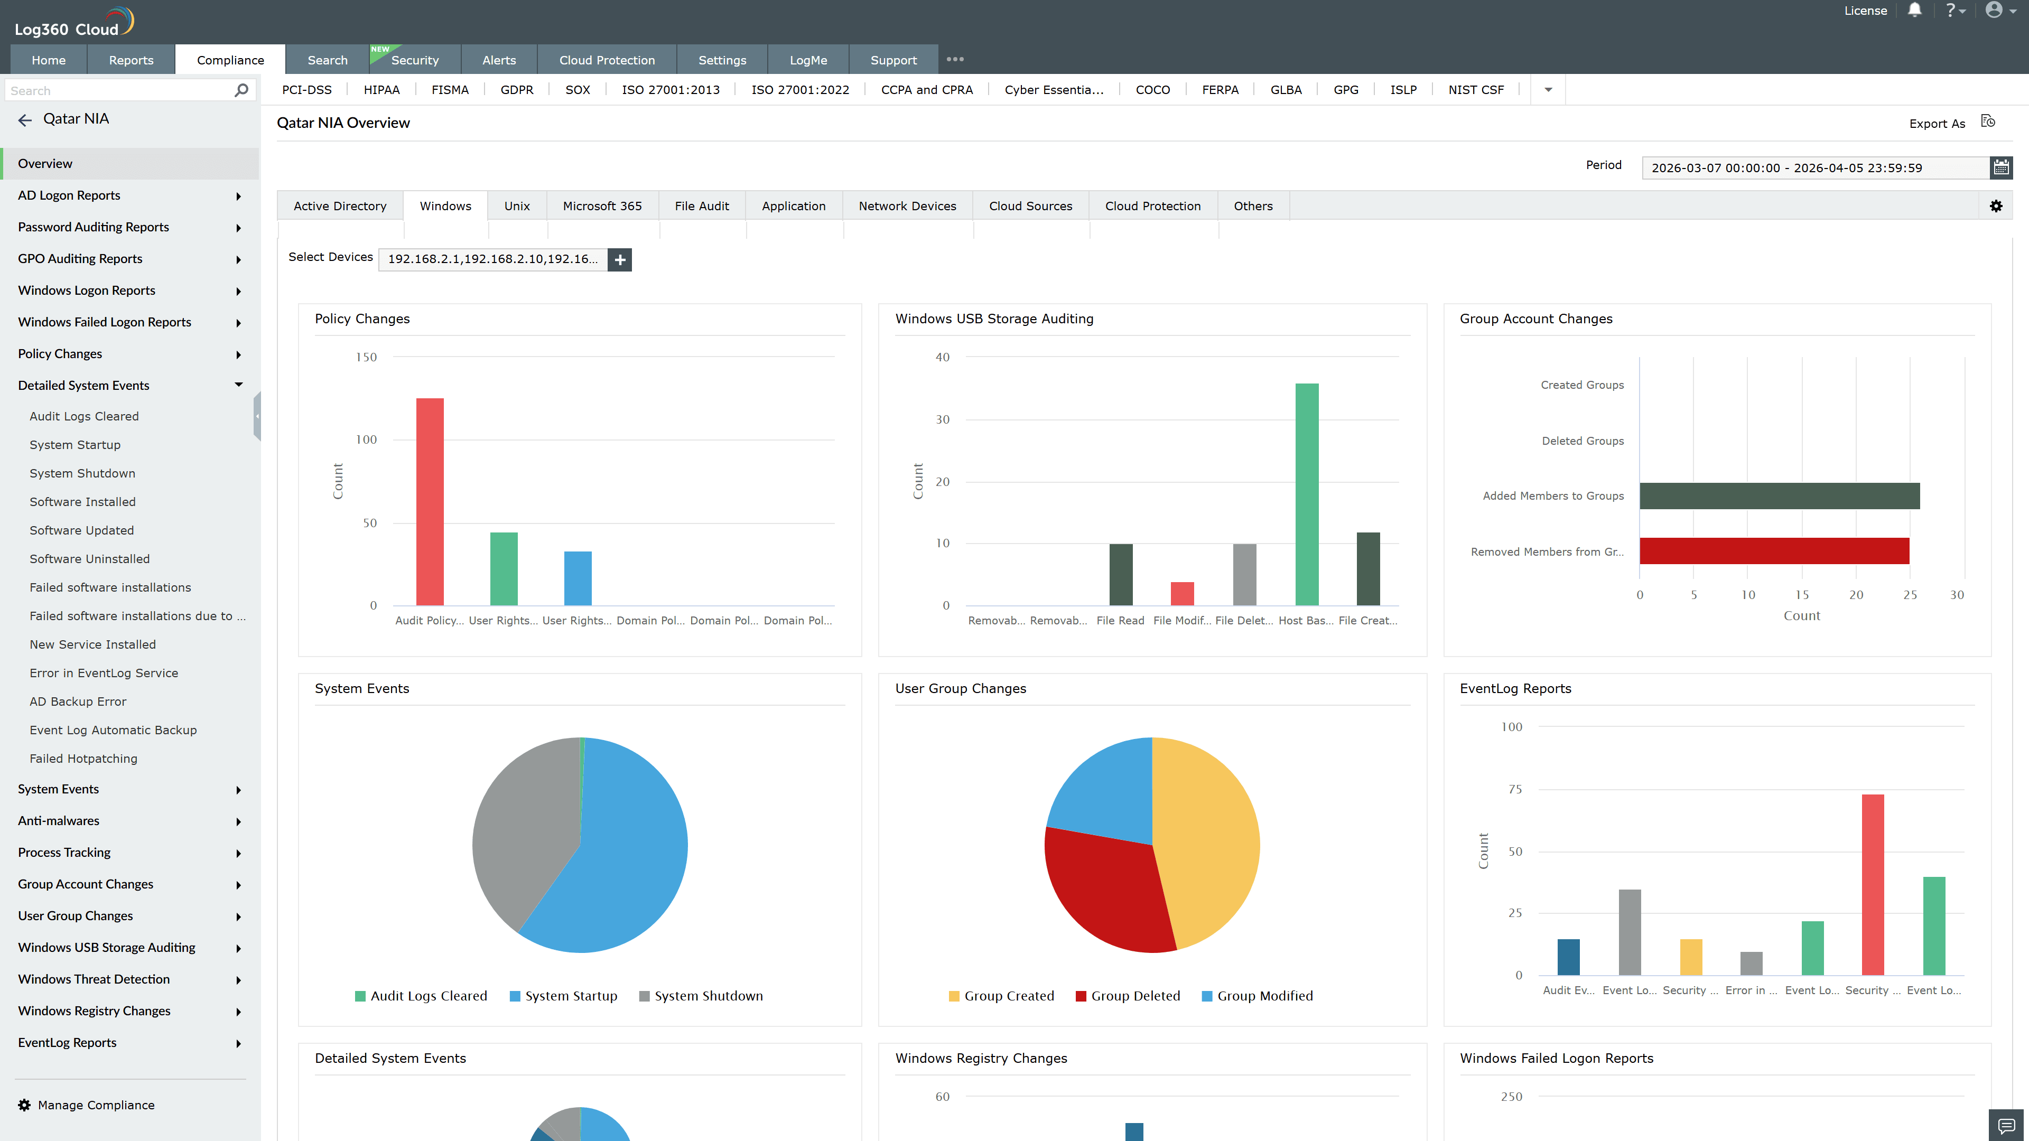
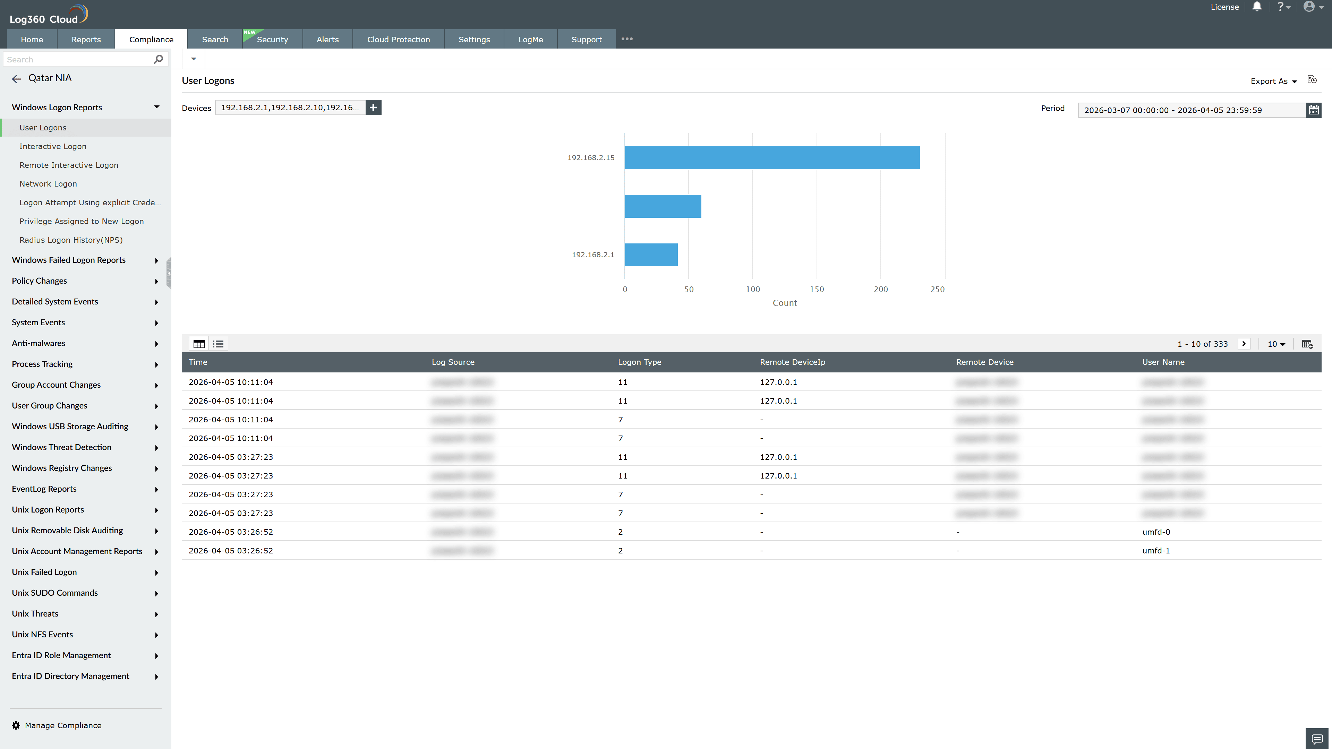
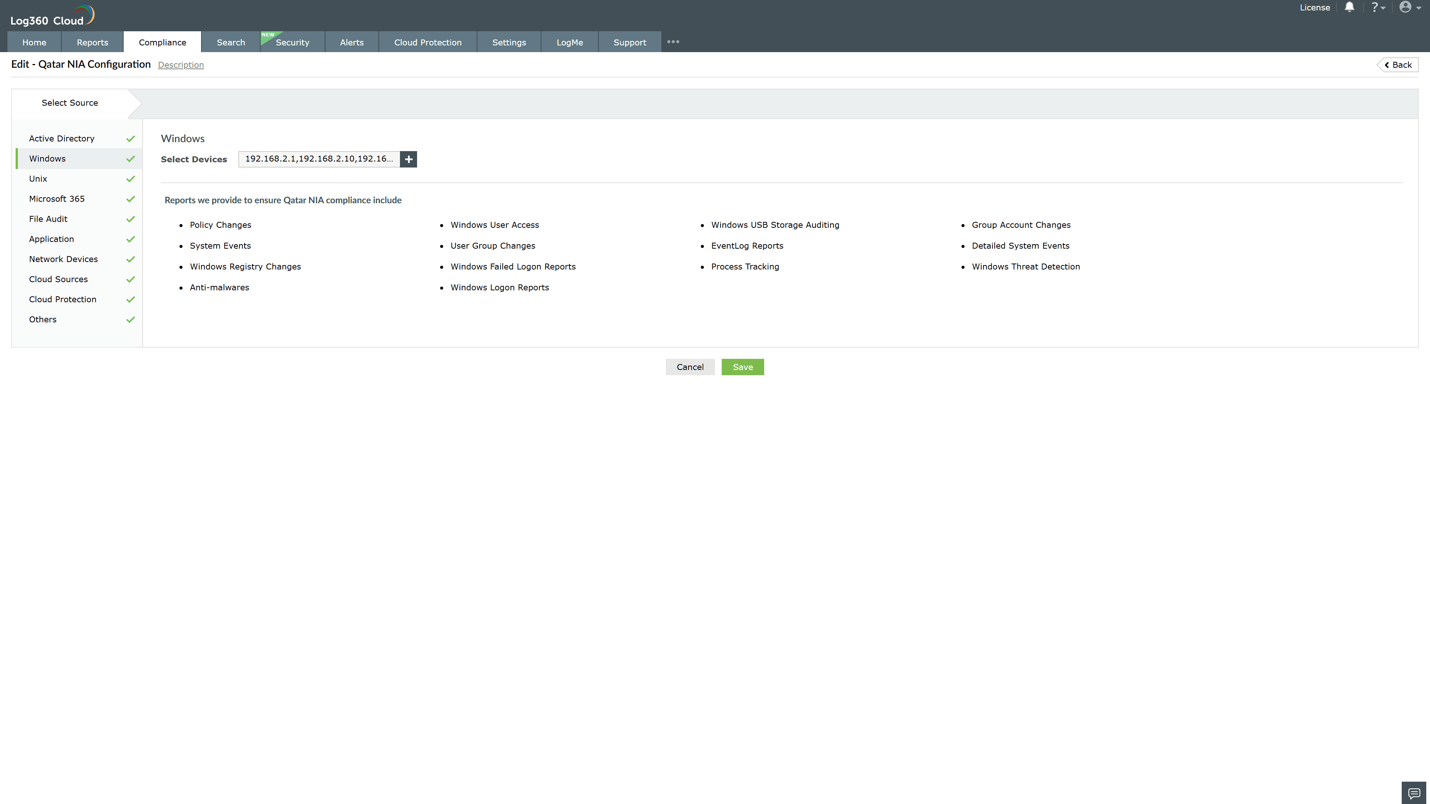
Valid Submission : Yes
Supported Editions : Free, Basic, Standard, Professional, MSSP
Help Document : https://www.manageengine.com/log-management/help/integrations/compliance-extensions.html
Help Video : Not provided
Tags : Log360, Compliance, Privacy monitoring, Data privacy, Regulatory compliance
Supported DCs : US, IN, JP, CA, AU, UK and EU
Privacy Policy:
Terms of Service:
Release Notes:
Predefined reports for the Qatar NIA.

